What do we lie about the most – Infographics Show
Video link: https://www.youtube.com/watch?v=X4LO_ac6Dw0
SAVE FACE COVER UP WHITE LIE FOLLOW UP CATCH UP SPRING TO MIND SPLURGE DEFER CALL IT A DAY CUNNING NONCOMMITAL MIDRIFF ROLL OFF THE TONGUE FEEL REMORSE JUSTIFY A CON ARTIST HABBITUAL LIAR DISTRUST TACTFULL BETRAY BE FORTHRIGHT SNEAKY SHUN HINDSIGHT

COMPREHENSION:
What three statistics does the video mentions about lying according Pamela Meyer?
What are some of the most common reasons why people lie?

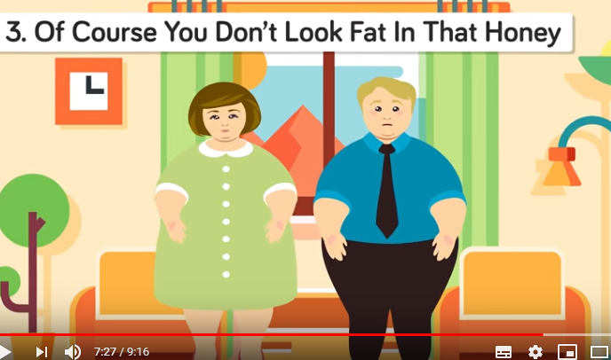
DISCUSSION:
Which lie used in the video do you find the most amusing?
How many times have you heard those lies?
How many times do you think you are being lied to in a single day?
Which one do you personally use the most and why?
What is your opinion on white lies?

