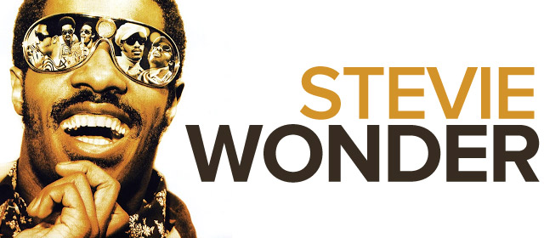
Stevland Hardaway Morris (born May 13, 1950, as Stevland Hardaway Judkins), known by his stage name Stevie Wonder, is an American musician, singer, songwriter, record producer, and multi-instrumentalist. He became one of the most creative and loved musical performers of the late 20th century.
He was born in Saginaw, Michigan, the third of six children. He was born six weeks premature and his eyes did develop correctly. He has been blind since shortly after birth.
Wonder signed with Motown at the age of 11 and has continued to perform and record for Motown as of the early 2010s.
He has recorded more than 30 U.S. top ten hits and received 25 Grammy Awards, the most ever awarded to a male solo artist, and has sold over 100 million albums and singles, making him one of the top 60 best-selling music artists. Wonder is also famous for his work as an activist for political causes, including his 1980 campaign to make Martin Luther King, Jr.'s birthday a holiday in the United States. In 2009, Wonder was named a United Nations Messenger of Peace.
Circle TRUE or FALSE about Stevie Wonder normal
- He was born as Stevland Hardaway Morris. TRUE / FALSE
- He was one of the most creative musical performers of the early 20th century. TRUE / FALSE
- He had 5 siblings. TRUE / FALSE
- He was born blind. TRUE / FALSE
- He stayed with the same record lable for the most of his musical career. TRUE / FALSE
- He is the best-selling music artist in the world. TRUE / FALSE
- He is a political activist. TRUE / FALSE
- He is a United Nations Messenger of Peace since 1980. TRUE / FALSE
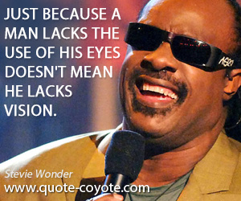
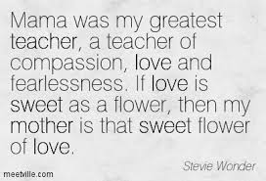
Circle TRUE or FALSE about Stevie Wonder easy
- He was born in June. TRUE / FALSE
- He was one was multi-instrumentalist. TRUE / FALSE
- There were six children in his family. TRUE / FALSE
- He is blind. TRUE / FALSE
- He started his musical career when he was 11 years old. TRUE / FALSE
- He received 30 Grammy Awards. TRUE / FALSE
- He sold over 100 million albums and singles. TRUE / FALSE
- He is a United Nations Messenger of Peace. TRUE / FALSE

normal
Order the lines 1-4:
__________No first of spring, no song to sing
__________No new years day to celebrate
__________In fact here's just another ordinary day
__________No chocolate covered candy hearts to give away
Fill in the gaps:
No April __________, no flowers bloom
No wedding Saturday within the month of ___________
But what it is, is something true
Made up of these three __________ that I must say to you
I just called to say I love you
I just called to say how much I care
I just called to say I love you
And I mean it from the bottom of my heart
Order the lines 1-4:
_________No autumn breeze, no falling leaves
_________No harvest moon to light one tender August night
_________Not even time for birds to fly to southern skies
_________No summer's high, no warm July

Fill in the gaps:
No Libra sun, no _____________
No giving thanks to all the Christmas joy you ___________
But what it is though old so new
To fill your _________ like no three words could ever do
I just called…
I just called … Of my heart, baby of my heart
EASY
Fill in the gaps:
No new years __________ to celebrate
No chocolate covered candy hearts to give away
No first of spring, no song to _________
In fact here's just another ordinary day
No April rain, no flowers bloom
No wedding ______________ within the month of June
But what it is, is something true
Made up of these three words that I must ________ to you
I just called to say I love you
I just called to say how much I care
I just called to say I love you
And I mean it from the bottom of my heart
NIGHT
NEW
LEAVES
SUN
WARM
BIRDS
BRING

Fill in the gaps with the words from the box:
No summer's high, no _________ July
No harvest moon to light one tender August _______
No autumn breeze, no falling __________
Not even time for _________ to fly to southern skies
No Libra ___________, no Halloween
No giving thanks to all the Christmas joy you ________
But what it is though old so __________
To fill your heart like no three words could ever do
I just called …
I just called … Of my heart, baby of my heart

