The Great Lakes
The Great Lakes are the five largest lakes in the United States and include Lake Superior, Lake Huron, Lake Michigan, Lake Erie, and Lake Ontario. They are located in the northern Midwest along the border between the United States and Canada.
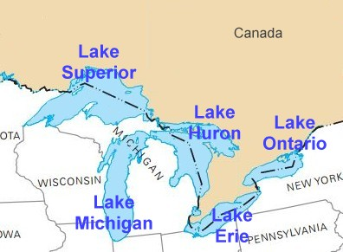
When all of the Great Lakes are combined, they make up the largest collection of freshwater lakes in the world. They cover over 94,000 square miles of surface area. The total volume of the lakes makes up around 21% of the world's surface freshwater.
Lake Superior is the largest of the Great Lakes covering 31,700 square miles.

Great Salt Lake
The largest lake in the United State that is not part of the Great Lakes is the Great Salt Lake in Utah. The water in the Great Salt Lake is salty. It is even more salty than the ocean. Because it is so salty, no fish live in the lake.
Crater Lake
Crater Lake is the deepest lake in the United States at 1,943 feet deep. It is formed from the collapsed land at the centre of a volcano. It is a quite small lake at only 6 miles long and 5 miles wide.

Lake Okeechobee
Lake Okeechobee is a large lake located in south Florida. It is the second largest natural freshwater lake that completely resides within the United States. Despite being such a large lake, Lake Okeechobee is very shallow. Its average depth is only 9 feet. The lake is home to a wide variety of wildlife including alligators, large-mouth bass, herons, cranes, white-tailed deer, manatees, river otters, and bobcats.

Answer:

What is the deepest lake in the US?
________________________________________________________
Which lake has no fish and why?
________________________________________________________
Name the five Great Lakes.
________________________________________________________
Which is the largest lake in the US?
________________________________________________________
Where is lake Okeechobee located?
________________________________________________________
Which lake was formed at the volcano?
________________________________________________________

