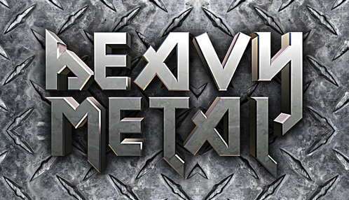
Heavy metal developed in the late 1960s and early 1970s, largely in the United Kingdom and the United States. It is a type of rock music with the electric guitar as the main musical instrument. The bands that created heavy metal developed a thick, massive sound, characterized by highly amplified distortion, long guitar solos, heavy beats, and loudness. Heavy metal lyrics and performance styles are often associated with masculinity, aggression, and machismo. The lyrics of heavy metal music can be sometimes difficult to understand because of the vocal technique used.
The first heavy metal bands such as Led Zeppelin, Black Sabbath and Deep Purple attracted large audiences. Heavy metal fans became known as "metalheads" or "headbangers".
By the 1980s, other subtypes of heavy metal appeared, such as "glam metal," "death metal" and "trash metal." The appearance of these sub-genres, different sounds and new groups made it hard to define the real "heavy metal sound." Bands such as Bon Jovi, Guns N' Roses, Metallica, Nirvana and Whitesnake had a different sound but are still categorized as "metal."
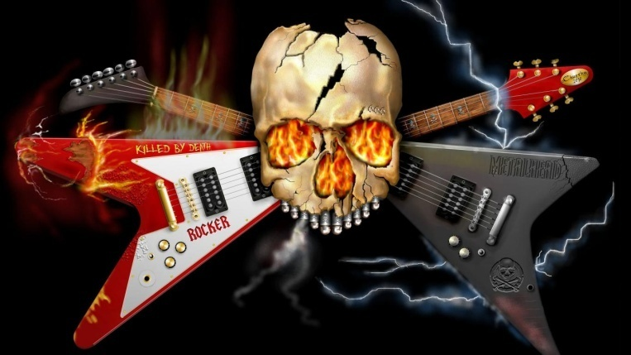

Find the antonyms in the text:
EARLY_______________ QUIETNESS______________
SIMILAR______________ SMALL___________________
LAST________________ DISAPPEARANCE_______________

Answer TRUE or FALSE:
„Trash metal“ is a subtype of heavy metal. TRUE / FALSE
Nirvana was the first heavy metal band. TRUE / FALSE
It is easy to define real heavy metal. TRUE / FALSE
All heavy metal singers are aggressive. TRUE / FALSE
Metallica is categorized as „metal“. TRUE / FALSE

Answer the questions about heavy metal:
What are the characteristics of heavy metal?
__________________________________________________________________________________________________________________________________________________________________________
What happened when subtypes of heavy metal appeared?
__________________________________________________________________________________________________________________________________________________________________________

EASY
Find the antonyms in the text:
LIGHT_______________ THIN______________
SHORT______________ NEVER______________
EASY________________ OLD_______________

Answer TRUE or FALSE:
Heavy metal developed mainly in USA and UK. TRUE / FALSE
It is a type of POP music. TRUE / FALSE
It is easy to understand the lyrics. TRUE / FALSE
Heavy metal fans are known as „metalheads“. TRUE / FALSE
The first heavy metal bands attracted big audiences. TRUE / FALSE

Answer the questions about heavy metal:
When did heavy metal developer?
________________________________________________
What is the main musical instrument?
_______________________________________________
Name three metal bands.
_______________________________________________

