Elvis Aaron Presley (January 8, 1935 – August 16, 1977) was an American singer and actor. Regarded as one of the most significant cultural icons of the 20th century, he is often called "the King of Rock and Roll", or simply, "the King".
Presley was born in Tupelo, Mississippi as a twinless twin, and when he was 13 years old, he and his family moved to Memphis, Tennessee. His music career began there in 1954. He was the leading figure of rock and roll. His energized interpretations of songs and provocative performance style made him enormously popular.
Several years of prescription drug abuse seriously damaged his health, and he died in 1977 at the age of 42.
Presley is one of the most celebrated and influential musicians of the 20th century. Commercially successful in many genres, he is the best-selling solo artist in the history of recorded music, with estimated record sales of around 600 million units worldwide. He won three Grammys. Elvis Presley is the 2nd top earning dead celebrity with $55 million in 2014, behind only Michael Jackson ($140 million).

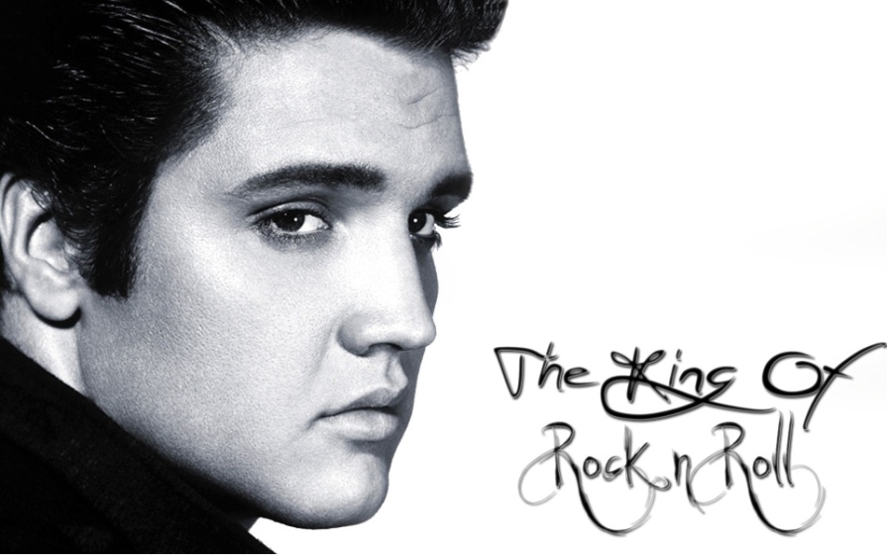

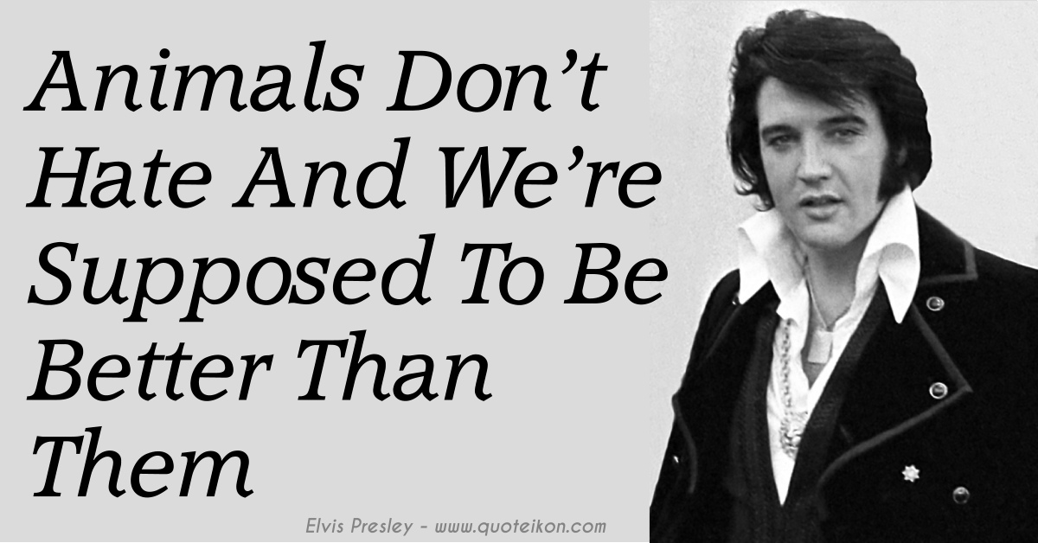

Answer questions about Elvis easy

What was his job?
________________________________

When and where was he born?

________________________________

When did he die?

________________________________

Does he earn more than Michael Jackson?

________________________________

Which century did he live in?

________________________________

Answer questions about Elvis

How was he called?
________________________________

When did his family move to Memphis?

________________________________

Why did he die? How old was he?

________________________________

Was he successful only in rock music?

________________________________

How many of his records were sold?

________________________________

Elvis Presley

Blue Suede Shoes
Well, it's one for the _______,
Two for the show,
Three to get ready,
Now _____, cat, ______.
But don't you step on my blue suede shoes.
You can do anything but lay off of my blue suede shoes.
Well, you can knock me ____________,
Step in my face,
Slander my name
All over the __________.
Do ____________ that you want to do, but uh-uh,
Honey, lay off of my shoes
Don't you step on my blue suede shoes.
You can do anything but lay off of my blue suede shoes.
You can burn my __________,
Steal my car,
________ my liquor
From an old fruitjar.
Do ____________ that you want to do, but uh-uh,
Honey, lay off of my shoes
Don't you step on my blue suede shoes.
You can do anything but lay off of my blue suede shoes.

Elvis Presley

Blue Suede Shoes easy
Well, it's _____ for the money,
________ for the show,
________ to get ready,
Now go, cat, go.
But don't you step on ________ blue suede shoes.
You can do anything but lay off of my blue suede shoes.
Well, _______ can knock me down,
Step in my face,
Slander my _________
All over the place.
Do anything that _______ want to do, but uh-uh,
Honey, lay off of my shoes
Don't you step on my blue suede shoes.
You can do anything but lay off of my blue suede shoes.
You can burn ______ house,
Steal _____ car,
Drink _____ liquor
From an old fruitjar.
Do anything that _______ want to do, but uh-uh,
Honey, lay off of my shoes
Don't you step on my blue suede shoes.
You can do anything but lay off of my blue suede shoes.

