https://www.youtube.com/watch?v=r7qovpFAGrQ
Fill in the be going to = BE GONNA with the correct verb:
Chorus:
Yeah, I ________________________ my horse to the old town road
I________________________ 'til I can't no more
I________________________ my horse to the old town road
I________________________ 'til I can't no more (Kio, Kio)
Fill in the clothes vocabulary:
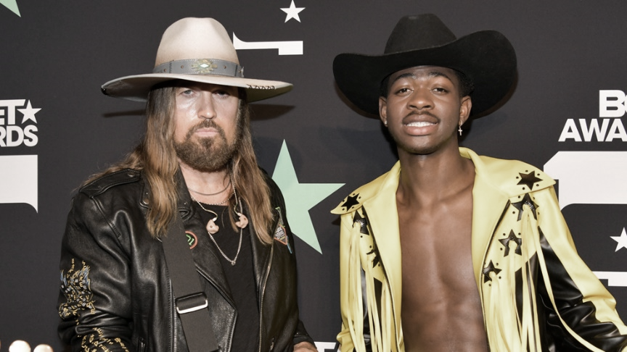
I got the horses in the back
Horse tack is attached
___________ is matte black
Got the ___________ that's black to match
Ridin' on a horse, ha
You can whip your Porsche
I been in the valley
You ain't been up off that porch, now
Fill in the personal pronouns:
Can't nobody tell ________ nothin'
________ can't tell ________ nothin'
Can't nobody tell ________ nothin'
________ can't tell ________ nothin'
Order the sentences:

_______My life is a movie
_______Cowboy hat from Gucci
_______Ridin' on a tractor
_______Lean all in my bladder
_______You can go and ask her
_______Cheated on my baby
_______Wrangler on my booty
_______Bull ridin' and boobies
Repeat: Can't nobody …… and Chorus: Yeah, I……………
Choose the words you hear:
Hat down, cross time / town , livin' like a rock star
Spent a lot of money on my brand new guitar
Baby's got a habit: diamond rings / things and Fendi sports bras
Ridin' down Rodeo in my Maserati sports car
Got no stress, You´ve / I've been through all that
I'm like a Marlboro Man so I kick on back
Wish I could roll on deck / back to that old town road
I wanna ride 'til I can't no more
Chorus: Yeah, I……………

KEY:
Yeah, I'm gonna take my horse to the old town road
I'm gonna ride 'til I can't no more
I'm gonna take my horse to the old town road
I'm gonna ride 'til I can't no more (Kio, Kio)
I got the horses in the back
Horse tack is attached
Hat is matte black
Got the boots that's black to match
Ridin' on a horse, ha
You can whip your Porsche
I been in the valley
You ain't been up off that porch, now
Can't nobody tell me nothin'
You can't tell me nothin'
Can't nobody tell me nothin'
You can't tell me nothin'
Ridin' on a tractor
Lean all in my bladder
Cheated on my baby
You can go and ask her
My life is a movie
Bull ridin' and boobies
Cowboy hat from Gucci
Wrangler on my booty
Can't nobody tell me nothin'
You can't tell me nothin'
Can't nobody tell me nothin'
You can't tell me nothin'
Yeah, I'm gonna take my horse to the old town road
I'm gonna ride 'til I can't no more
I'm gonna take my horse to the old town road
I'm gonna ride 'til I can't no more
I got the
Hat down, cross town, livin' like a rock star
Spent a lot of money on my brand new guitar
Baby's got a habit: diamond rings and Fendi sports bras
Ridin' down Rodeo in my Maserati sports car
Got no stress, I've been through all that
I'm like a Marlboro Man so I kick on back
Wish I could roll on back to that old town road
I wanna ride 'til I can't no more
[Lil Nas X & Billy Ray Cyrus:]
Yeah, I'm gonna take my horse to the old town road
I'm gonna ride 'til I can't no more
I'm gonna take my horse to the old town road
I'm gonna ride 'til I can't no more

