Fill in the missing sentences, there are two extra sentences. FCE part 6 missing sentences
Coca-Cola history began in 1886 when the curiosity of an Atlanta pharmacist, Dr. John S. Pemberton, led him to create a distinctive tasting soft drink that could be sold at soda fountains. 1__________
The name of Coca-Cola was a suggestion given by Pemberton's bookkeeper Frank Robinson. As the recipe for the syrup called for coca leaf extract and caffeine from the kola nut, the name Coca Kola was easy to come up with 2__________ .
The first servings of Coca-Cola were sold for 5 cents per glass. During the first year, sales averaged a modest nine servings per day in Atlanta. Today, daily servings of Coca-Cola beverages are estimated at 1.9 billion globally.
Prior to his death in 1888, just two years after creating what was to become the world’s #1-selling sparkling beverage, Dr. Pemberton sold portions of his business to various parties, with the majority of the interest sold to Atlanta businessman, Asa G. Candler. 3__________. In 1894, impressed by the growing demand for Coca-Cola and the desire to make the beverage portable, Joseph Biedenharn installed bottling machinery in the rear of his Mississippi soda fountain, becoming the first to put Coca-Cola in bottles.
While the Coca-Cola Company denies this claim, historical evidence shows that it is likely that, until 1905, the soft drink, which was marketed as a tonic, contained extracts of cocaine as well as the caffeine-rich kola nut. 4__________ . Traces of cocaine may have been present in the famous beverage until 1929 when scientists were able to perfect the removal of all psychoactive elements from the coca-leaf extract.
A However, Robinson, who was known for having excellent penmanship, thought that using two Cs in the name would look striking in advertising.
B While cocaine wasn't considered illegal until 1914, according to Live Science, Candler began removing cocaine from the recipe in the early 1900s.
C Dr Pemberton tried it out on customers at his local chemist, Jacobs' Pharmacy, where it proved so popular it immediately went on sale at five cents a glass.
D He created a flavored syrup, took it to his neighborhood pharmacy, where it was mixed with carbonated water and deemed “excellent” by those who sampled it.
E Under his leadership, distribution of Coca-Cola expanded to soda fountains beyond Atlanta.
F He wrote it out by hand in the Spencerian script that we still use as our logo.

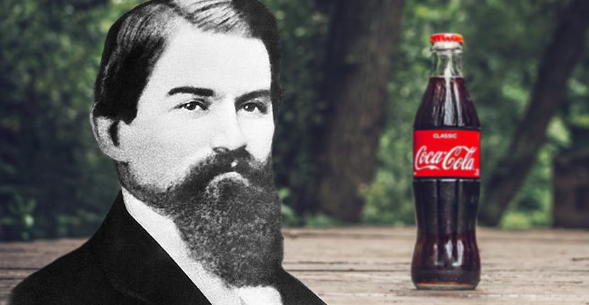
Study the vocabulary:
whosie whatsit
Temperance
Invigorating
Snake oil

Watch the video and answer the questions.
Video link: https://www.youtube.com/watch?v=2HZ_r66lKSo&feature=youtu.be
COMPREHENSION QUESTIONS:
- What’s the original idea behind Pemberton’s invention?
- Who’s recipe did he copy after he started using coca leaves?
- Why couldn’t he sell his original recipe in Atlanta?
- What’s the dog’s name?
DISCUSSION:
- What do you think John Pemberton would think about Coca Cola now?
- Is Coca Cola the most popular soft drink worldwide?
- Do you drink Coca Cola?
- Nowadays Coca Cola’s recipe is a really big secret. What do you think they’re hiding?

Answers:
Coca-Cola history began in 1886 when the curiosity of an Atlanta pharmacist, Dr. John S. Pemberton, led him to create a distinctive tasting soft drink that could be sold at soda fountains. He created a flavored syrup, took it to his neighborhood pharmacy, where it was mixed with carbonated water and deemed “excellent” by those who sampled it.
The name of Coca-Cola was a suggestion given by Pemberton's bookkeeper Frank Robinson. As the recipe for the syrup called for coca leaf extract and caffeine from the kola nut, the name Coca Kola was easy to come up with. However, Robinson, who was known for having excellent penmanship, thought that using two Cs in the name would look striking in advertising.
The first servings of Coca-Cola were sold for 5 cents per glass. During the first year, sales averaged a modest nine servings per day in Atlanta. Today, daily servings of Coca-Cola beverages are estimated at 1.9 billion globally.
Prior to his death in 1888, just two years after creating what was to become the world’s #1-selling sparkling beverage, Dr. Pemberton sold portions of his business to various parties, with the majority of the interest sold to Atlanta businessman, Asa G. Candler. Under his leadership, distribution of Coca-Cola expanded to soda fountains beyond Atlanta. In 1894, impressed by the growing demand for Coca-Cola and the desire to make the beverage portable, Joseph Biedenharn installed bottling machinery in the rear of his Mississippi soda fountain, becoming the first to put Coca-Cola in bottles.
While the Coca-Cola Company denies this claim, historical evidence shows that it is likely that, until 1905, the soft drink, which was marketed as a tonic, contained extracts of cocaine as well as the caffeine-rich kola nut. While cocaine wasn't considered illegal until 1914, according to Live Science, Candler began removing cocaine from the recipe in the early 1900s. Traces of cocaine may have been present in the famous beverage until 1929 when scientists were able to perfect the removal of all psychoactive elements from the coca-leaf extract.

