The United States is often divided up into geographical regions. Using these regions can help to describe a larger area and also helps to group together states that are similar in features such as geography, culture, history, and climate.
Major Regions
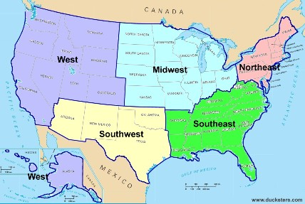
Northeast
- Climate: Humid continental climate with cool summers in the northernmost areas. Snow falls during the winter because the temperatures are usually below freezing.
- Major geographical features: Appalachian Mountains, Atlantic Ocean, Great Lakes, borders on Canada to the north
Southeast
- Climate: Humid subtropical climate with hot summers. Hurricanes can reach landfall in the summer and fall months along the Atlantic and Gulf coasts.
- Major geographical features: Appalachian Mountains, Atlantic Ocean, Gulf of Mexico, Mississippi River
Midwest
- Climate: Humid continental climate throughout most of the region. Snow is common during the winter, especially in the northern areas.
- Major geographical features: Great Lakes, Great Plains, Mississippi River, borders Canada to the north
Southwest
- Climate: Semiarid Steppe climate in the western area with a more humid climate to the east. Some of the far western areas of the region have an alpine or desert climate.
- Major geographical features: Rocky Mountains, Colorado River, Grand Canyon, Gulf of Mexico, borders Mexico to the south
West
- Climate: A range of climates including semiarid and alpine along the Rocky and Sierra Mountains. The coastline in California is a Mediterranean climate. Desert climates can be found in Nevada and Southern California.
- Major geographical features: Rocky Mountains, Sierra Nevada Mountains, Mohave Desert, Pacific Ocean, borders Canada to the North and Mexico to the south

Answer:

Name the regions with continental climate?
________________________________________________________
Name the regions with mountains?
________________________________________________________
Which regions border Mexico?
________________________________________________________
Which regions border Canada?
________________________________________________________
Which regions border Atlantic Ocean?
________________________________________________________
Which regions border Pacific Ocean?
________________________________________________________

