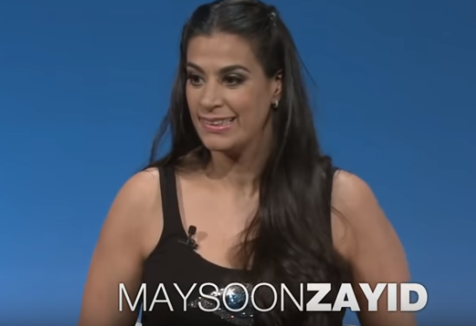
video link: https://www.youtube.com/watch?v=buRLc2eWGPQ
COMPREHENSION QUESTIONS:
1. What happened to her during her birth?
2. What are some of her problems?
3. How did her parents make sure that she would lead a normal life?
4. Where did she spend her summer vacations and what did she do there?
5. Why didn´t she get the role of a girl with CP?
6. What motivated her to become a comic?
7. What happened to her during and after her first news show „Countdown with Keith Olbermann“?
8. What are some of her achievements?
DISCUSSION QUESTIONS:
Some people use term „physically challenged“. What do you think?
Do you think i tis harder to live with a physical disability or intellectual one?
Do you tend to think that disabled people always need your help?
What misunderstandings do people have about disability?

Maysoon Zayid: “We are not making history, we are changing the story”
“People with disabilities are the largest minority in the world,” Maysoon Zayid says. Born with cerebral palsy and a great acting talent, she decided to change Hollywood… and the world.
When did you first realize that you are different from others, or that they were different from you?
I didn’t realize that I was different from others until I was 16. That’s when people started treating me differently. I knew that I had problems walking, and I knew that I would shake. 1___________ However, when I grew up, as a teenager, living outside of my parents’ home, at high school, I knew that being disabled was a big deal. When it was time for me to cook, I couldn’t handle knives and boiling water.
Your family gave you strong belief that “you can” (do anything). Has that faith grown in you over the years?
I believe that if my parents had not sent me to public school, I would not be here today as an advocate for the disabled. I remember the meeting with the principal of my school when I was 5 years old, in kindergarten. 2__________ My father sued the school and finally I got the chance to go there.
My parents could not afford physical therapy, so they sent me to attend performance classes. My parents always encouraged me: “You can do it, yes you can can”!
My father is a humorous and brave man and my mother is a strict tiger mother. They love me 3.___________.
You are widely thought to be the first Muslim woman comedian in the United States. Do you see laughter as a remedy?
Being a Palestinian comedian in the US is controversial. But comedy is mostly about talking about your personal story, so no one can stop me from talking about being a Palestinian! 4__________ Nowadays, worldwide, people’s ability to speak freely is being censored. But comedy is powerful.
I have been told that every time a comedian gets off a stage, their energy is drained and some suffer from depression. I never suffer that way, because my life is not only about comedy. I am very attached to my family and friends. I am dedicated to fighting for the rights of people with disabilities and I am dedicated to fighting violence against women.
One of the things I say over time is that if someone is laughing, they are less likely to kill you. If you can get your enemy to laugh, they are less likely to hunt you, to hate you. 5__________ You can’t change everybody, but I have changed a lot of people.

Put the sentences in thein correct place in the text:
A. When I started doing stand-up comedy, I immediately realized the power I had.
B. When I was little, people around me treated me as an equal.
C. I have changed people’s minds.
D. He said I couldn’t go to public school, but I had to go to a school for children with Down syndrome.
E. However, I want to let disabled people know that even if your family abandons you, it is not the end of the world.

Key:
Maysoon Zayid: “We are not making history, we are changing the story”
“People with disabilities are the largest minority in the world,” Maysoon Zayid says. Born with cerebral palsy and a great acting talent, she decided to change Hollywood… and the world.
When did you first realize that you are different from others, or that they were different from you?
I didn’t realize that I was different from others until I was 16. That’s when people started treating me differently. I knew that I had problems walking, and I knew that I would shake. When I was little, people around me treated me as an equal. However, when I grew up, as a teenager, living outside of my parents’ home, at high school, I knew that being disabled was a big deal. When it was time for me to cook, I couldn’t handle knives and boiling water.
Your family gave you strong belief that “you can” (do anything). Has that faith grown in you over the years?
I believe that if my parents had not sent me to public school, I would not be here today as an advocate for the disabled. I remember the meeting with the principal of my school when I was 5 years old, in kindergarten. He said I couldn’t go to public school, but I had to go to a school for children with Down syndrome. My father sued the school and finally I got the chance to go there.
My parents could not afford physical therapy, so they sent me to attend performance classes. My parents always encouraged me: “You can do it, yes you can can”!
My father is a humorous and brave man and my mother is a strict tiger mother. They love me. However, I want to let disabled people know that even if your family abandons you, it is not the end of the world.
You are widely thought to be the first Muslim woman comedian in the United States. Do you see laughter as a remedy?
Being a Palestinian comedian in the US is controversial. But comedy is mostly about talking about your personal story, so no one can stop me from talking about being a Palestinian! When I started doing stand-up comedy, I immediately realized the power I had. Nowadays, worldwide, people’s ability to speak freely is being censored. But comedy is powerful.
I have been told that every time a comedian gets off a stage, their energy is drained and some suffer from depression. I never suffer that way, because my life is not only about comedy. I am very attached to my family and friends. I am dedicated to fighting for the rights of people with disabilities and I am dedicated to fighting violence against women.
One of the things I say over time is that if someone is laughing, they are less likely to kill you. If you can get your enemy to laugh, they are less likely to hunt you, to hate you. I have changed people’s minds. You can’t change everybody, but I have changed a lot of people.

