Source: Wikipedia
Fill in the gaps with the correct prepostions:
The Egg is a short story _____ American writer Andy Weir, originally published _____ his website Galactanet _____ August 15, 2009. It is Weir's most popular short story, and has been translated _____ over 30 languages by readers. The rapper Logic used The Egg as inspiration for the album ‘Everybody’ released _____ 2017, Weir himself appearing _____ the album's cover. Kurzgesagt made an animation based _____ the story with Weir's permission, which was released _____ September 1, 2019.
The story is _____ the main character, who is "you" (in the second person), and God, who is "me" (in the first person). "You", a 48-year-old man who dies _____ a car crash, meets the narrator, who says that "you" have been reincarnated many times before, and that "you" are next to be reincarnated as a Chinese peasant girl _____ 540 AD. God then explains that "you" are, _____ fact constantly reincarnated across time, and that all human beings who have ever lived and will ever live are incarnations of "you". "You" remark _____ being Abraham Lincoln, Adolf Hitler and Jesus, and God adds that "you" were also once John Wilkes Booth, every Holocaust victim and every person who followed Jesus. God explains that _____ fact there are other Godlike beings elsewhere, and that "you" too will one day become a God. The entire universe was created _____ an egg for the main character (all of humanity), and once "you" have lived every human life ever, "you" will be born _____ a God. The reason God created the universe was for the main character, "you," to understand this point: "Every time you victimized someone...you were victimizing yourself. Every act of kindness you’ve done, you’ve done to yourself. Every happy and sad moment ever experienced _____ any human was, or will be, experienced _____ you."

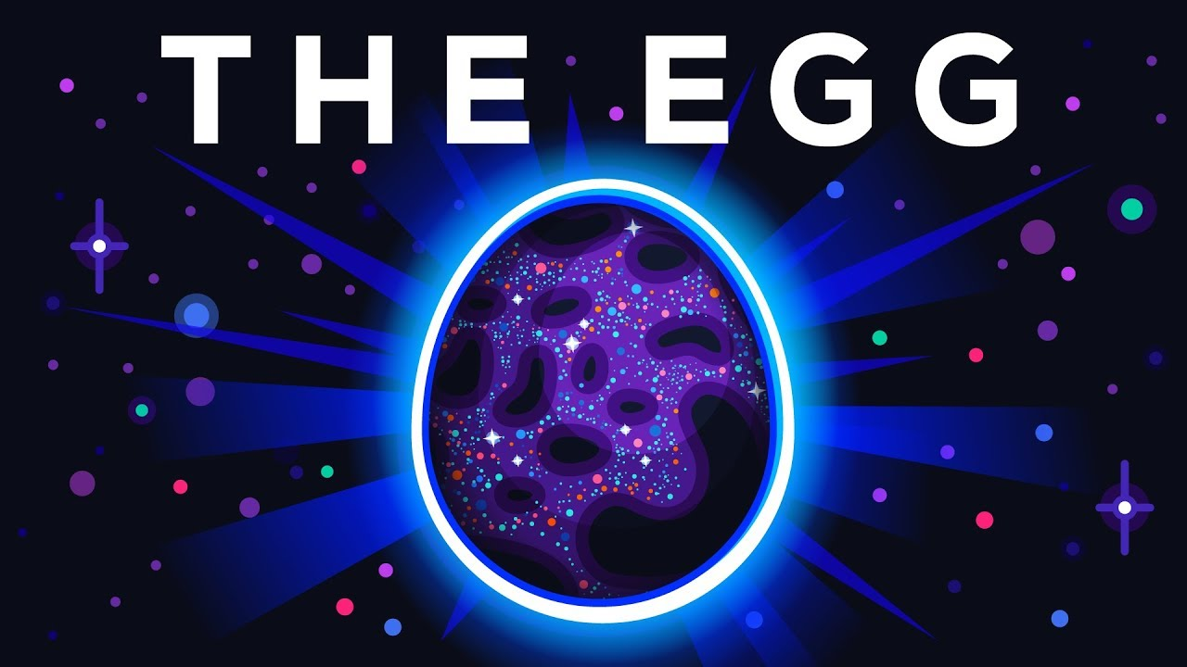
Match the words with their deffinitions:
1 | TO NO AVAIL | A | To speak vaguely or indirectly
2 | TO BE BETTER OFF | B | Horrified
3 | MINCING WORDS | C | To be in a better situation
4 | CONTEMPTUOUS | D | Of no use or advantage
5 | APPALLED | E | Unable to believe something
6 | INCREDULOUS | F | Expressing deep hatred or disapproval
Watch the video and answer the questions:
Video link: https://youtu.be/h6fcK_fRYaI
COMPREHENSION QUESTIONS:
- How did the man die? How old was he?

- Why did God like the fact that the man worried about his family?

- Will the man remember his past lives after he’s reborn?

- Why does God say that his past lives are like putting a finger in a glass of water?

- What is the meaning of life according to the video?

DISCUSSION:
- Do you agree with the video?
- Have you ever heard of the “Egg Theory”?
- What other theories have you heard of this topic?
- What do you think of the afterlife?
- What would the ideal situation be like after life?

Answers:
The Egg is a short story by American writer Andy Weir, originally published on his website Galactanet on August 15, 2009. It is Weir's most popular short story, and has been translated into over 30 languages by readers. The rapper Logic used The Egg as inspiration for the album ‘Everybody’ released in 2017, Weir himself appearing on the album's cover. Kurzgesagt made an animation based on the story with Weir's permission, which was released on September 1, 2019.
Summary
The story is about the main character, who is "you" (in the second person), and God, who is "me" (in the first person). "You", a 48-year-old man who dies in a car crash, meets the narrator, who says that "you" have been reincarnated many times before, and that "you" are next to be reincarnated as a Chinese peasant girl in 540 AD. God then explains that "you" are, in fact constantly reincarnated across time, and that all human beings who have ever lived and will ever live are incarnations of "you". "You" remark about being Abraham Lincoln, Adolf Hitler and Jesus, and God adds that "you" were also once John Wilkes Booth, every Holocaust victim and every person who followed Jesus. God explains that in fact there are other Godlike beings elsewhere, and that "you" too will one day become a God. The entire universe was created as an egg for the main character (all of humanity), and once "you" have lived every human life ever, "you" will be born as a God. The reason God created the universe was for the main character, "you," to understand this point: "Every time you victimized someone...you were victimizing yourself. Every act of kindness you’ve done, you’ve done to yourself. Every happy and sad moment ever experienced by any human was, or will be, experienced by you."

