Match the phrases with their deffinitions:
1 | LURE INTO | A | To become chaotic and unmanageable
2 | PLAY OFF LIKE something else | B | to be going to happen or do something very soon
3 | PUT INTO | C | to entice or bait someone
4 | GET OUT OF CONTROL | D | To be similar to
5 | BE ABOUT TO | E | To try to escape in order to survive
6 | SET UP | F | To place in
7 | RAN FOR someone’s LIVE | G | to trick someone to incriminate or deceive them

Now fill in the phrases in the text in the correct form:
Scare Tactics is a hidden camera prank show that _____ victims _____ terrifying situations, usually involving movie-style special effects and makeup that recreates horror movie clichés. The victims, generally four per episode, are __________ by friends/family in tandem with producers.
Unlike other hidden camera shows, Scare Tactics was shot and edited in a cinematic style intended to give each piece the look and feel of a scary movie.
There are some instances where the victims are __________ the pranks on the promise of being on a fake reality show called "Fear Antics" ________________ a show similar to MTV's Jackass but end with dire consequences. Sometimes, the victim will attempt keeping calm and rationally try keeping the situation from ________________ (from their perspective).
The pranks end when the victim is completely terrified and someone would ask them, "Are you scared?" to which they usually reply in the affirmative. They then get the reply, "You shouldn't be! You're on Scare Tactics!" or "I'll have to/I'm gonna put you on Scare Tactics!". Alternately, at times when a victim almost _______ their _______, they immediately announced the same thing. At least once or twice, a victim immediately realized that they were on Scare Tactics when the ruse ____________ be revealed.

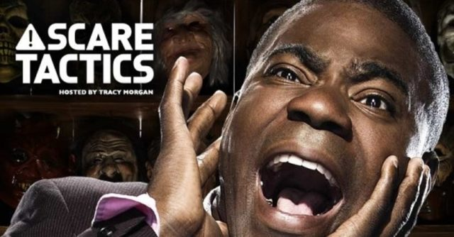
Watch the video: https://youtu.be/8h9NNKG_tNE
COMPREHENSION QUESTIONS:
- Who was the accomplice?
- Where was Karrina heading?
- What are reasons the cop gives the cab driver for closing down the road?
- What did Karrina say she was going to do with her shoe?
DISCUSSION:
- Do you like pranks?
- Have you ever played a joke on someone else?
- Has anyone ever played a joke on you?
- Do you enjoy being scared?
- Who is the funniest person you know? What makes them funny?
- Do you laugh when other people suffer misfortune?
- How do you feel about clowns? Funny or scary?
- How do you react when someone tells a bad joke? Do you laugh to be polite?
- Do you enjoy dark humour? Why do you think people sometimes enjoy joking about topics like death?

Answers:
Comprehension;
- Who was the accomplice? Karrina’s friend Ashley
- Where was Karrina heading? She was going to an invitation-only party
- What are reasons the cop gives the cab driver for closing down the road? He gives him some very vague reasons, mentioning “incidents”
- What did Karrina say she was going to do with her shoe? Throw it at whoever came through the window.

Answers:
Scare Tactics is a hidden camera prank show that puts victims into terrifying situations, usually involving movie-style special effects and makeup that recreates horror movie clichés. The victims, generally four per episode, are set up by friends/family in tandem with producers.
Unlike other hidden camera shows, Scare Tactics was shot and edited in a cinematic style intended to give each piece the look and feel of a scary movie.
There are some instances where the victims are lured into the pranks on the promise of being on a fake reality show called "Fear Antics" which plays off like a show similar to MTV's Jackass but end with dire consequences. Sometimes, the victim will attempt keeping calm and rationally try keeping the situation from getting out of control (from their perspective).
The pranks end when the victim is completely terrified and someone would ask them, "Are you scared?" to which they usually reply in the affirmative. They then get the reply, "You shouldn't be! You're on Scare Tactics!" or "I'll have to/I'm gonna put you on Scare Tactics!". Alternately, at times when a victim almost ran for their lives, they immediately announced the same thing. At least once or twice, a victim immediately realized that they were on Scare Tactics when the ruse was about to be revealed.

