video link: https://www.youtube.com/watch?v=sNhhvQGsMEc
COMPREHENSION QUESTIONS:
- Why is the video primarily focusing on the Milky Way?
- What comparison is used to illustrate the number of stars?
- Explain the three different types of civilizations according to the Kardashev Scale. Where do we belong?
- How long would it take us to become a Type 3 civilization?
- Explain the two main ideas behind the Great Filter theory.

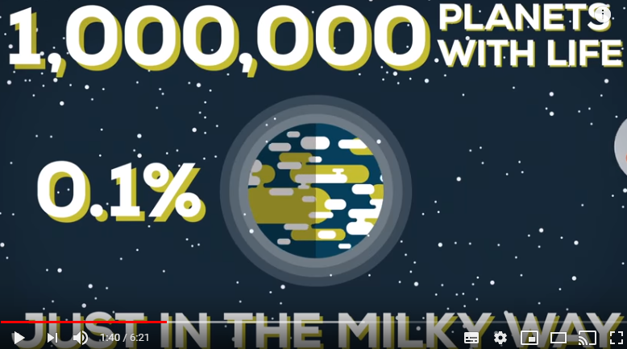

DISCUSSION:
Do you believe we are alone in the Universe?
If we aren´t alone why haven´t we heard from other civilizations?
What´s your take on the Great Filter theory?
Do you think we will one day become a Type 3 civilization?
Do you think we will ever be able to find out what is really going on out there?

